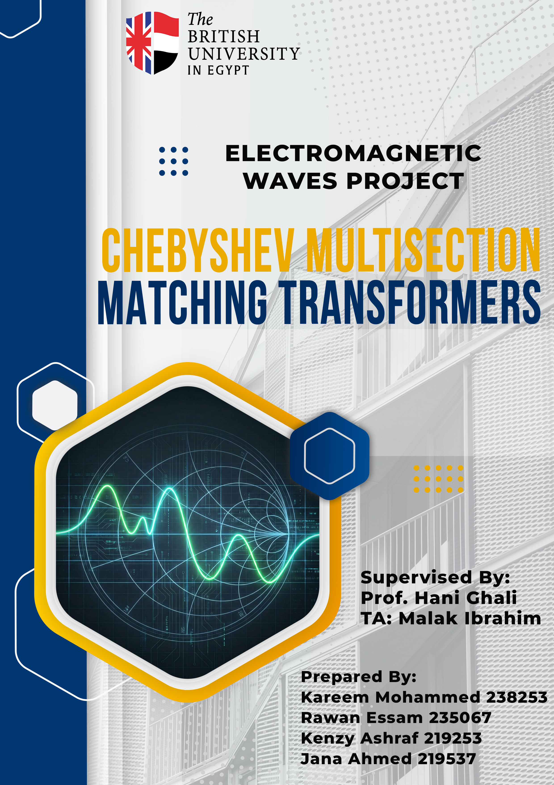

Table of Contents

1. Theory and Concept 3

1.1. Objective 3

1.2. Chebyshev Polynomials 3

1.3. Complex Load Analysis 3

2. Used Design (Methodology) 4

2.1. Bandwidth and Constants 4

2.2. The reflection coefficients are used in 4

2.3. Section Impedances $Zn$: 5

3. Output Results 5

3.1. Dataset Generation 5

3.2. Graphical Analysis 5

3.3. AI Model Verification 6

3.3.1. AI Model Output 6

3.3.2. Manual Calculations 7

3.3.3. Comparison between AI Model Values and Manual Calculations Values 7

3.3.4. Interactive Design Interface (GUI) 8

4. Conclusion 10

5. References 10

Table of Figures

Figure 1 First 5 rows of the dataset generated by MatLab 5

Figure 2 Chebyshev Response vs Number of Sections (N) 6

Figure 3 AI Model Outputs 6

Figure 4 The developed Streamlit Interface: Design Parameters 8

Figure 5 The developed Streamlit Interface:AI predictions and theoretical validation 8

Figure 6 The developed Streamlit Interface: Accuracy Verification (% Error) 9

Figure 7 The developed Streamlit Interface: Frequency Response (Chebyshev) 9

Table of Tables

Table 1 Comparison between AI Model Values and Manual Calculations Values 7

# Theory and Concept

## Objective

This project aims at the design of a broadband impedance-matching network based on the Chebyshev multi-section transformer. Compared to binomial transformers, which have a response that is maximally flat, Chebyshev transformers have a broader band by permitting controlled ripple in the passband1. This project uses a computational tool in the design of a 5-section transformer (N=5) of complex load impedances.

## Chebyshev Polynomials

The frequency response of the reflection coefficient has been shaped, depending upon the characteristics of Chebyshev polynomials. These polynomials lie between $±1$ in a normalized domain, which produces the prerogative equal ripple characteristic.

General Recurrence Formula: The higher-order polynomials are obtained in terms of the recursive relation:

$$T_{n}(x)=2xT_{n-1}(x)-T_{n-2}(x)$$

From Applied (N=5): In this 5-section design the 5th-order expansive is expanded as:

$$T_{5}(x)=16x^{5}-20x^{3}+5x$$

## Complex Load Analysis

Standard Chebyshev designs take into consideration real load impedances. To accommodate complex loads ($Z_{L}$) in this project, the design is done based on the magnitude of the reflection coefficient. This guarantees the bandwidth demands that are associated with the scale of the mismatch.

General Reflection Coefficient: $Γ_{L}=\frac{Z_{L}-Z_{0}}{Z_{L}+Z_{0}}$

Magnitude (Design Basis): $\left|Γ_{L}\right|=\left|\frac{Z_{L}-Z_{0}}{Z_{L}+Z_{0}}\right|$

# Used Design (Methodology)

The implementation of the design process in MATLAB was done with Small Reflection Theory. The algorithm is applied in the given order to determine characteristic impedances ($Z_{1} to Z_{5}$ ​).

## Bandwidth and Constants

The initial step is the bandwidth scaling factor which is referred to as Chebyshev constant (S). This is based on the given maximum ripple ($a_{m}=0.05$) and the value of the load mismatch that was determined in the theory part.

Passband Edge $(sec{θm})$:

$$sec⁡(θ_{m})=cosh⁡\left(\frac{1}{N}{cosh⁡}^{-1}\left(\frac{1}{Γ_{m}}\left|\frac{Z_{L}-Z_{0}}{Z_{L}+Z_{0}}\right|\right)\right)$$

Chebyshev Constant (S):

$$S=cosh⁡\left(\frac{1}{5}{cosh⁡}^{-1}\left(\frac{\left|Γ_{L}\right|}{a_{m}}\right)\right)$$

## The reflection coefficients are used in

With Small Reflection Theory, the overall reflection is broken down in the reflection at the local steps of the transmission line.

General Approximation: In the case of small discontinuities, the local reflection coefficient is roughy approximated as:

$$Γ_{n}≈\frac{1}{2}ln⁡\left(\frac{Z_{n+1}}{Z_{n}}\right)$$

Calculation (Application of Symmetry $Γ_{n}=Γ_{N-n}$):

Using $N=5$, the reflection coefficients are symmetric which are determined as:

$$Γ_{0}=Γ_{5}=\frac{a_{m}}{2}S^{5}$$

$$Γ_{1}=Γ_{4}=\frac{a_{m}}{2}(5S^{5}-5S^{3})$$

$$Γ_{2}=Γ_{3}=\frac{a_{m}}{2}(10S^{5}-15S^{3}+5S)$$

## Section Impedances $\left(Z_{n}\right)$:

Lastly, the calculus of the characteristic impedance of each section is done in an iterative manner starting with the characteristic impedance $Z_{0}$.

Iterative Calculation:

$$Z_{1}=Z_{0}⋅e^{2Γ_{0}} \\ Z_{2}=Z_{1}⋅e^{2Γ_{1}} \\ Z_{3}=Z_{2}⋅e^{2Γ_{2}} \\ Z_{4}=Z_{3}⋅e^{2Γ_{3}} \\ Z_{5}=Z_{4}⋅e^{2Γ_{4}}$$

# Output Results

## Dataset Generation

A sample of 250 entries was created. The data contains the Characteristic Impedance ($Z_{0}=85Ω$), and the Real (from 30Ω to 280Ω) and Imaginary (from -60jΩ to 190jΩ) components of the load impedance ($Z_{L}$) in decreasing order, and the respective calculated section impedances ().

Figure First 5 rows of the dataset generated by MatLab

## Graphical Analysis

The frequency response of different number of sections ($N=1\text{ to }N=5$) was simulated. The plot above shows that as $N$ is increased, the bandwidth is greatly maximized but the ripple limit of 0.05 remains unchanged.

Figure Chebyshev Response vs Number of Sections (N)

## AI Model Verification

A neural network model was trained on the data created. To check accuracy, a test load ($Z_{L}=300+j200\text{Ω}$) was tested beyond the training range. The AI model predictions have been used to compare the results with the manual calculations of the equations.

### AI Model Output

Figure AI Model Outputs

### Manual Calculations

$$Γ_{L}=\frac{Z_{L}-Z_{0}}{Z_{L}+Z_{0}}=\frac{(300+j200\text{Ω}\text{)}-85Ω}{(300+j200\text{Ω}\text{)}+85Ω}=0.6523+j0.1806=0.676815.479°$$

$$\left|Γ_{L}\right|=\left|\frac{Z_{L}-Z_{0}}{Z_{L}+Z_{0}}\right|=0.6768$$

$$S=\cosh\left(\frac{1}{5}\cosh^{-1}\left(\frac{\left|Γ_{L}\right|}{a_{m}}\right)\right)=cosh\left(\frac{1}{5}\cosh^{-1}\left(\frac{0.6768}{0.05}\right)\right)=1.2254$$

$$Γ_{0}=Γ_{5}=\frac{a_{m}}{2}S^{5}=\frac{0.05}{2}{*1.2254}^{5}=0.06907$$

$$Γ_{1}=Γ_{4}=\frac{a_{m}}{2}\left(5S^{5}-5S^{3}\right)=\frac{0.05}{2}\left(5*{1.2254}^{5}-5*{1.2254}^{3}\right)=0.11537$$

$Γ_{2}=Γ_{3}=\frac{a_{m}}{2}\left(10S^{5}-15S^{3}+5S\right)=\frac{0.05}{2}\left(10{*1.2254}^{5}-15*{1.2254}^{3}+5*1.2254\right)=0.1539$

$$Z_{1}=Z_{0}⋅e^{2Γ_{0}}=85*e^{2*0.06907}=97.591Ω \\ Z_{2}=Z_{1}⋅e^{2Γ_{1}}=97.591*e^{2*0.11537}=122.919Ω \\ Z_{3}=Z_{2}⋅e^{2Γ_{2}}=122.919*e^{2*0.1539}=167.222Ω \\ Z_{4}=Z_{3}⋅e^{2Γ_{3}}=167.222*e^{2*0.1539}=227.493Ω \\ Z_{5}=Z_{4}⋅e^{2Γ_{4}}=227.493*e^{2*0.11537}=286.534Ω$$

### Comparison between AI Model Values and Manual Calculations Values

Table Comparison between AI Model Values and Manual Calculations Values

|  |  |  |  |
| --- | --- | --- | --- |
| Characteristic Impedances | AI Model Values | Manual Calculations Values | %Error |
| $$Z_{1}$$ | $$97.708Ω$$ | $$97.591Ω$$ | 0.1198% |
| $$Z_{2}$$ | $$123.499Ω$$ | $$122.919Ω$$ | 0.4718% |
| $$Z_{3}$$ | $$170.101Ω$$ | $$167.222Ω$$ | 1.721% |
| $$Z_{4}$$ | $$228.9725Ω$$ | $$227.493Ω$$ | 0.6503% |
| $$Z_{5}$$ | $$290.6976Ω$$ | $$286.534Ω$$ | 1.453% |

$$\text{\% Error}=\left(\frac{\left|\text{Manual}-\text{AI}\right|}{\text{Manual}}\right)×100\%$$

### Interactive Design Interface (GUI)

To make the proposed model more usable, the Graphical User Interface (GUI) was created with the help of the Streamlit framework in Python. With this application, engineers can operate with the model in real-time without interacting with the underlying code.

The following are the important features of the application:

* User Inputs: It has sidebar values of Characteristic Impedance ($Z_{0}$) and Complex Load Impedance ($Z_{L}$) enabling the live exploration of the different load situations.

Figure The developed Streamlit Interface: Design Parameters

* Real-Time Inference: The Neural Network is loaded, and it instantly predicts the five section impedances ().

Figure The developed Streamlit Interface:AI predictions and theoretical validation

* Automated Validation: The system calculates both theoretical values using the equations of the Small Reflection Theory as in Section 2. It then compiles automatically an error comparison table (in the same way as Table 1) giving instant validation of the accuracy of the AI.

Figure The developed Streamlit Interface: Accuracy Verification (% Error)

* Dynamic Visualization: The application will plot Chebyshev frequency response of precise details of the user inputs and ensure that bandwidth and ripple needs ($a_{m}=0.05$) are achieved by the newly designed transformer.

Figure The developed Streamlit Interface: Frequency Response (Chebyshev)

# Conclusion

The project was able to design and implement a computational tool to a 5-section Chebyshev impedance matching transformer that could be used to match complex load impedances to a standard 85Omega transmission line. The design methodology was able to synthesize a corresponding network that meets the rigid ripple requirement of $a_{m}=0.05$ by using the magnitude of the reflection coefficient ($\left|Γ_{L}\right|$).

The MATLAB simulation showed that with large values of the number of sections ($N$) the bandwidth can be greatly increased and yet passband ripple set to the desired value, which validates the theoretical benefits of Chebyshev transformers over simpler matching methods. Moreover, the use of Artificial Intelligence in the design process was extremely productive. The model of AI created could forecast the characteristic impedances of unobservable complex loads with a high level of accuracy. The check of the calculation against manual theoretical calculations gave percentage errors of up to 0.1198% with $Z_{1}$ and 1.721% maximum error with $Z_{3}$. This is a small error, which confirms that the obtained dataset can be trusted and proves the fact that machine learning models can speed up the design of microwave components. Lastly, the effective implementation of the model into an interactive software interface is an indication of the practical implementation of this project, which can be a quick and easy tool to use to design corresponding networks.

# References

[1] D. M. Pozar, Microwave engineering. New York: John Wiley & Sons, 2012.